**Botswana country profile**

Published

3 April 2018

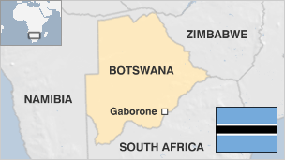

**Botswana, one of Africa's most stable countries, is the continent's longest continuous multi-party democracy. It is relatively free of corruption and has a good human rights record.**

Sparsely populated, Botswana protects some of Africa's largest areas of wilderness. Safari-based tourism - tightly-controlled and often upmarket - is an important source of income.

Botswana is the world's largest producer of diamonds and the trade has transformed it into a middle-income nation.

The country has had its share of problems: It once had the world's highest rate of HIV-Aids infection. UN figures for 2014 suggest that for adults aged 15 to 49 the prevalence rate is 25%.

The country has one of Africa's most-advanced treatment programmes, however, and medicine for the virus is readily available.

* Read [more country profiles](http://news.bbc.co.uk/1/hi/country_profiles/) - Profiles by [BBC Monitoring](http://www.bbc.co.uk/monitoring)

**President: Mokgweetsi Masisi**

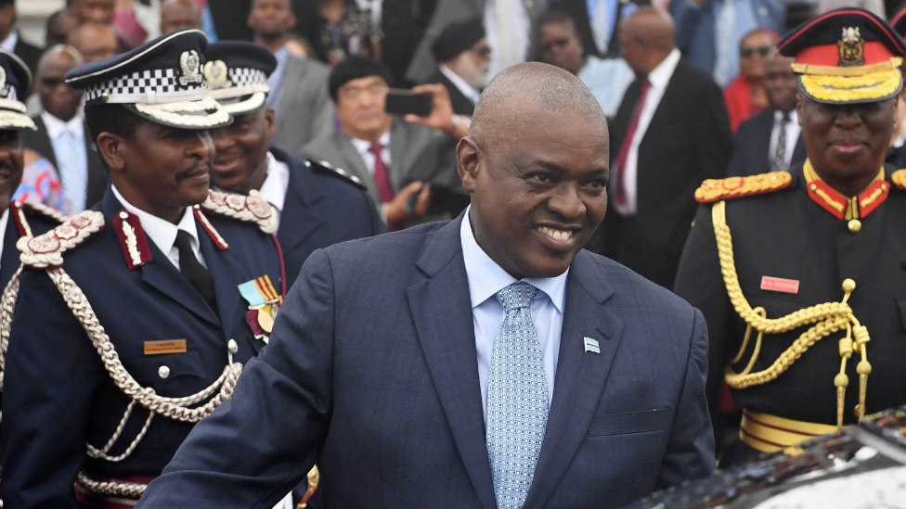image copyrightMONIRUL BHUIYAN/AFP/Getty Images

After serving as vice-president and education minister for four years under the presidency of Ian Khama, Mokgweetsi Masisi become the 5th president of Botswana in April 2018.

Like all of his predecessors, he represents the Botswana Democratic Party, which has also won a majority in every parliamentary election since independence.

Mr Masisi had a background in education before entering politics, and faces the task of diversifying an economy heavily dependent on the diamond trade.

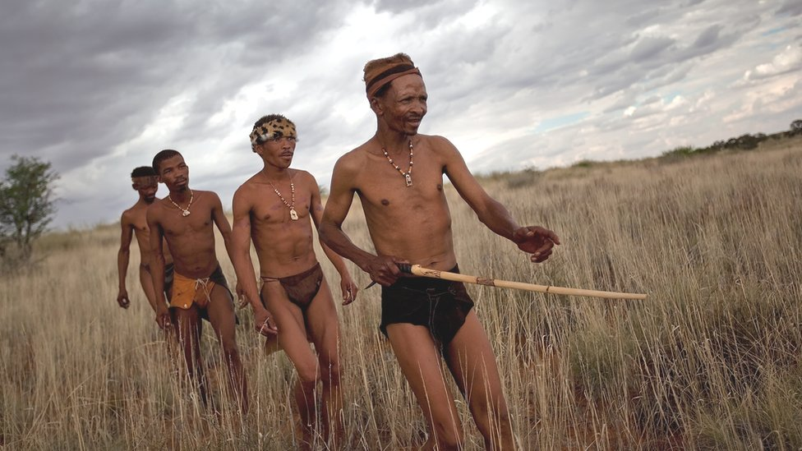image copyrightGetty Images

image captionCampaign groups say the authorities are forcing the Bushmen off their ancestral lands. A dwindling band of Bushmen hunter-gatherers make the Kalahari Desert their home

Botswana has a long tradition of lively and unimpeded public debate, although opposition leaders have claimed that the government limits their ability to broadcast freely on the radio.

There is a "free and vigorous" press in cities and towns, says US-based NGO Freedom House.

State-run TV arrived with the launch of Botswana Television (BTV) in 2000. Satellite pay TV is available.

# Botswana profile - Timeline

Published

20 September 2017

**A chronology of key events**

**1867** - European gold prospectors arrive, mining begins.

**1885** - British proclaim a protectorate called Bechuanaland.

**1890** - British protectorate is extended to Chobe river.

**1950** - Chief of the Ngwato, Seretse Khama, is deposed and exiled by the British.

**1952** - Rioters protest at Seretse Khama's exile.

**1959** - Copper mines are established.

**1960** - Bechuanaland People's Party (BPP) is established.

**1960** December - Britain approves new constitution for Bechuanaland. Executive Council, Legislative Council and African Council are established.

**1961** - Seretse Khama appointed to Executive Council.

**1962** - Seretse Khama founds Bechuanaland Democratic Party (BDP), later to become Botswana Democratic Party.

**1965** - Gaborone becomes administrative centre.

**1965** - BDP wins legislative elections, first to be held under universal adult suffrage. Seretse Khama becomes prime minister.

## Independence

**1966** September - Bechuanaland is granted independence and becomes Republic of Botswana with Seretse Khama as president.

**1967** - Diamonds discovered at Orapa.

**1969** August - BDP wins general election. Khama is re-elected for another term.

**1977** January - UN Security Council resolution demands Rhodesian hostilities on Botswana border cease.

**1977** March - Botswana Defence Force is established.

**1979** October - General elections: BDP wins majority, Khama is re-elected as president.

**1980** - Botswana is founder member of Southern African Development Coordination Conference (SADCC), grouping which aims to reduce region's economic reliance on South Africa.

**1980** - President Seretse Khama dies. Quett Masire, former vice-president, is made president after National Assembly vote.

**1984** September - General elections: BDP wins majority, Quett Masire is re-elected as president.

**1985** June - Buildings in Gaborone are raided and 12 people are killed by South African forces seeking alleged ANC members. Action is condemned by UN Security Council.

**1989** October - General elections; BDP wins majority. National Assembly re-elects Masire as president.

**1991** - 12,000 public sector workers sacked after strike action calling for increased wages.

**1994** October - Legislative elections: BDP secures 53% of vote. Masire re-elected by National Assembly.

## Kalahari relocations

**1995** - Government begins relocating thousands of bushmen to settlements outside Central Kalahari Game Reserve.

**1997** - Constitutional amendments approved. Presidency is limited to two five-year terms. Voting age lowered from 21 to 18.

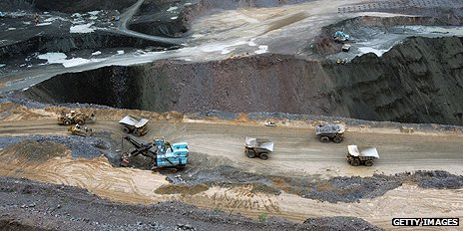image copyrightGetty Images

image captionThe open pit diamond mine at Jwaneng, 160km south west of Gaborone. Botswana is the world's biggest producer of diamonds

**1998** March/April - Masire resigns as president and retires. Festus Mogae, formerly vice president, becomes president under new constitutional arrangements.

**1998** June - Botswana Congress Party established after split in BNF and is declared official opposition after most BNF deputies switch allegiance.

**1999** September - Six-day state of emergency declared to resolve voter registration problem.

**1999** October - General elections: BDP wins majority, Festus Mogae is confirmed as president.

**1999** December - International Court of Justice grants control of Sedudu-Kasikili - a river island disputed by Botswana and Namibia - to Botswana.

**2000** February/March - Devastating floods: More than 60,000 are made homeless.

## Battle against Aids

**2000** August - President Mogae says Aids drugs will be made available free of charge from 2001.

**2001** March - National diamond corporation, Debswana, says it will subsidise drugs for workers with Aids.

**2002** March - Kalahari bushmen take the government to court to challenge a forced eviction from their land; the case is dismissed on a technicality.

**2003** September - Botswana begins erecting a fence along its border with Zimbabwe to stem an influx of Zimbabwean illegal immigrants.

**2004** March - HIV infection rate falls to 37.5%; Botswana no longer has the world's highest rate of infection.

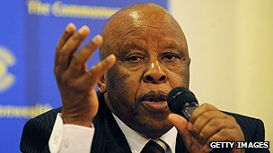image copyrightGetty Images

image captionFestus Mogae served two terms as prime minister

**2004** August - Workers at Botswana's largest diamond-mining company strike over pay, after a court rules that such action is illegal. Some 1,000 workers are sacked.

**2004** October - President Mogae secures a second term in a landslide election victory.

**2006** December - A group of Bushmen wins a four-year legal battle to hold on to their ancestral lands.

**2008** March - Botswana launches its own diamond trading company - the Diamond Trading Company Botswana (DTCB).

**2008** April - Seretse Khama Ian Khama takes over as president.

**2008** October - Botswana's former President Festus Mogae wins a $5m prize set up to encourage good governance in Africa.

**2009** April - Botswana says it will halve diamond production because of falling demands for gems.

**2009** October - Ruling BDP party wins elections, and another 5-year term for President Khama.

**2009** November - Botswana stages a substantial economic recovery after stepping up diamond production again, a bank reports.

**2010** November - Human rights group Survival International calls for a boycott of Botswanan diamonds, accusing the government of trying to force Basarwa bushmen away from their ancestral lands.

**2011** January - An appeals court in Botswana overturns a July 2010 order depriving the indigenous Basarwa bushmen of the right to drill for water on their ancestral land.

**2011** April - Civil servants begin what becomes a two-month strike over pay.

**2012** January - Talks by three main opposition parties aimed at forming coalition fail, destroying hopes of challenge to ruling Botswana Democratic Party.

**2012** November - Government says it will ban the commercial hunting of wildlife from 2014, citing a sharp decline in animal populations.

**2013** November - Global diamond giant De Beers completes the move of its rough stone sales operation from London to Gaborone, in what is seen as a step towards turning Botswana into one of the world's top diamond hubs.

**2014** July - Opposition leader Gomolemo Motswaledi dies in a car crash, just weeks before the general election. Police say it was an accident, his party suspects foul play.

**2014** September - Editor of the Sunday Standard is arrested after the paper reported that the president was involved in a car accident.

**2014** October - Ruling Botswana Democratic Party (BDP) wins the general elections with 33 of the 57 seats, giving Ian Khama a second term as president.

**2014** November - Gay rights group wins legal recognition.

**2018** April - Mokgweetsi Masisi becomes president and leader of the governing Botswana Democratic Party.